Opening aws ec2 service

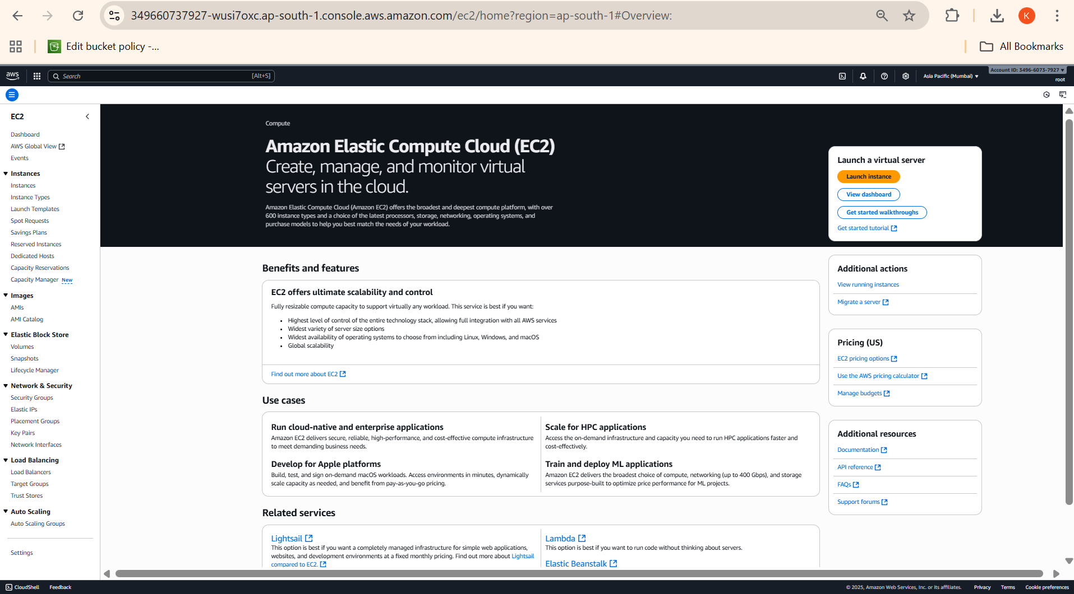

Launching instance with linux server

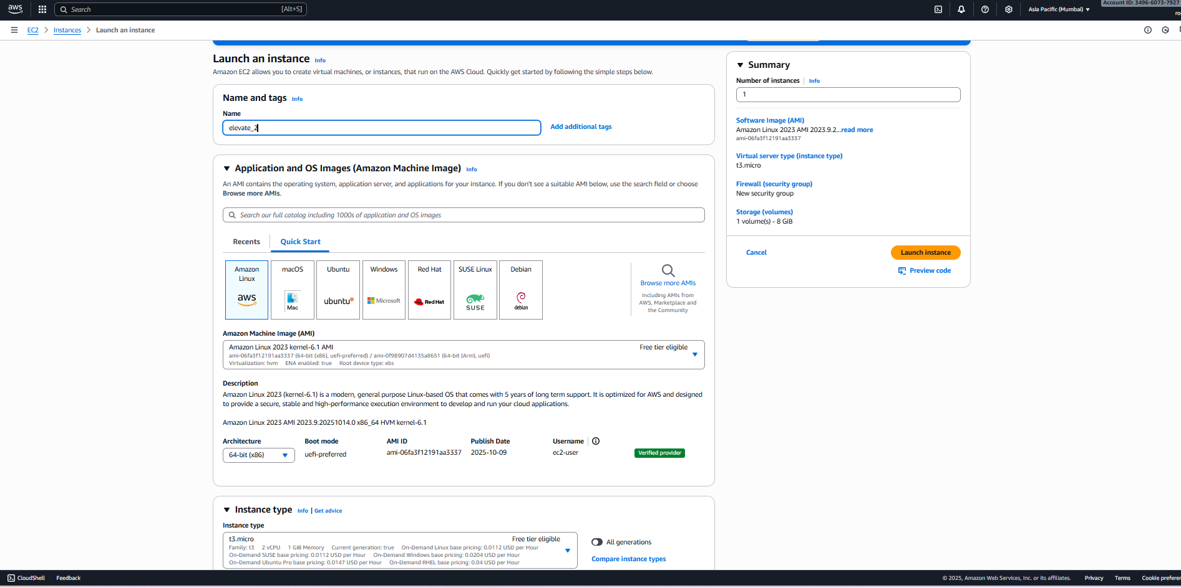

Creating security group, keypair, storage

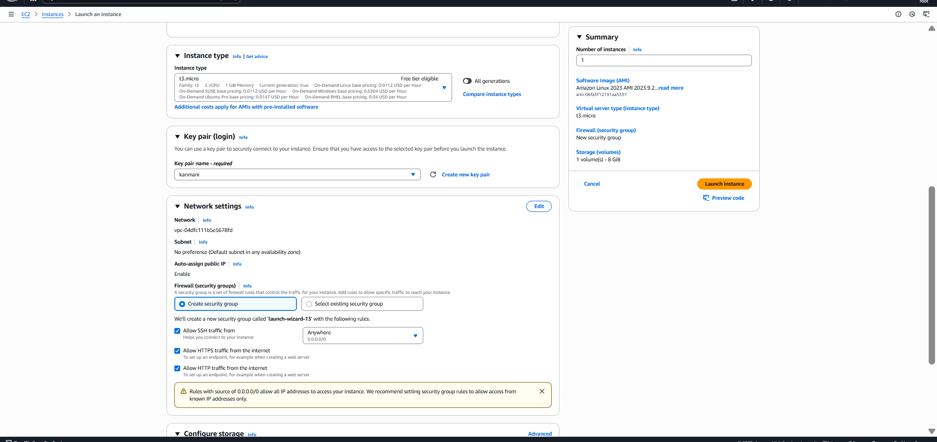

Launching instance

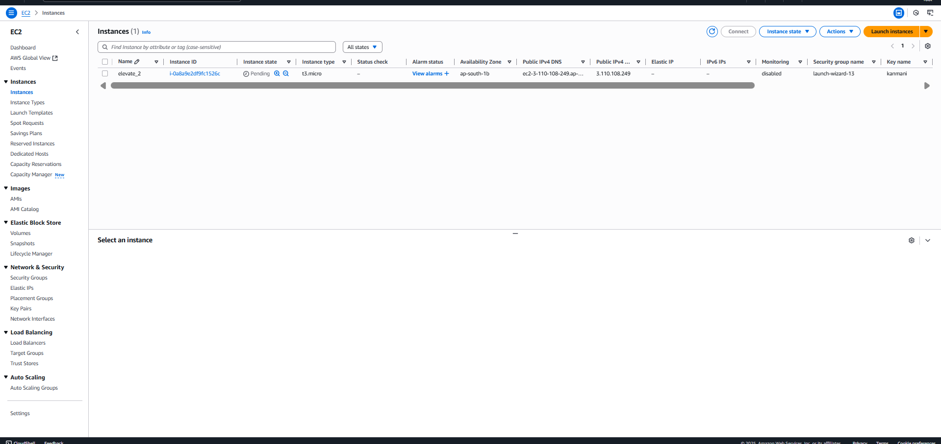

Instance launched successfully

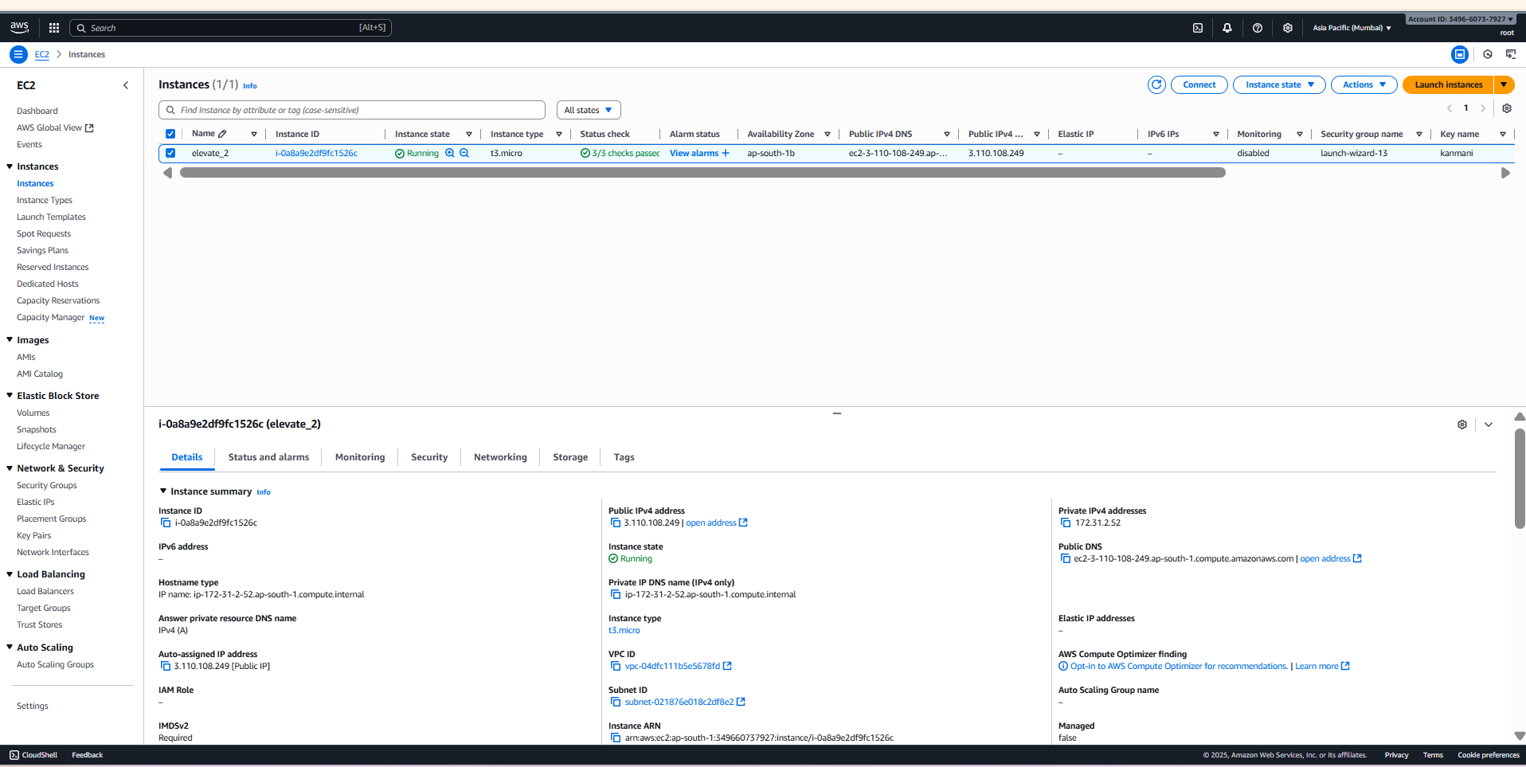

Detail of the instance

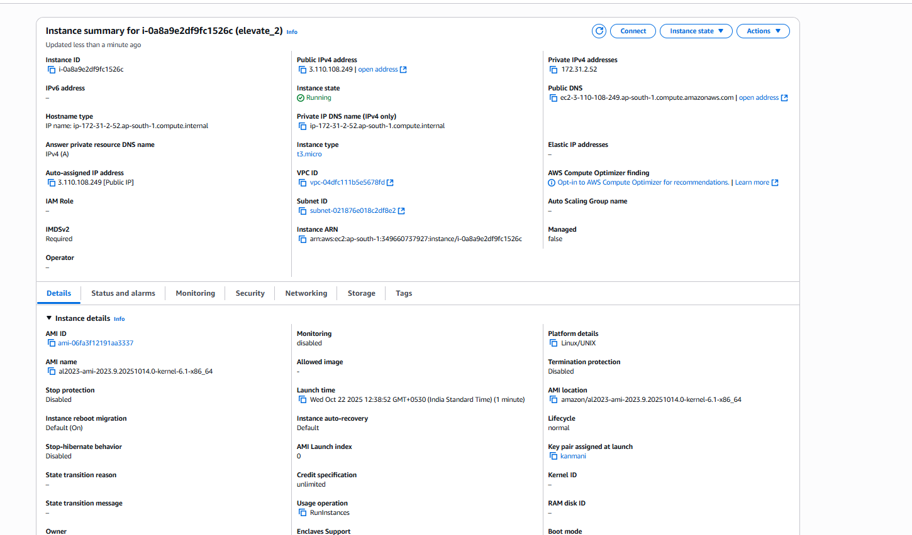

Remote server login link:

ssh -i "kanmani.pem" ec2-user@ec2-3-110-108-249.ap-south-1.compute.amazonaws.com